*Salary Prediction Based on Experience Using Regression Analysis.*

**SULAIMAN ABID FA18-BCS-098**

**MUHAMMAD TALHA FA18-BCS-069**

In this final report we will show the trends that we achieved after applying regression model to our project.

**Overview:**

In this project we will be using dataset that we found from the internet. We train the training and testing data to show that the model is linear. We will plot the result on using matplot lib to show the relation between the Salary and the Years of Experience for every Employee. At the end we will also check the percentage of the the testing and predicting variable to see if the graph is perfectly FIt or not.

**Showing Trends using heatmap**



**Trends on scatter plot**

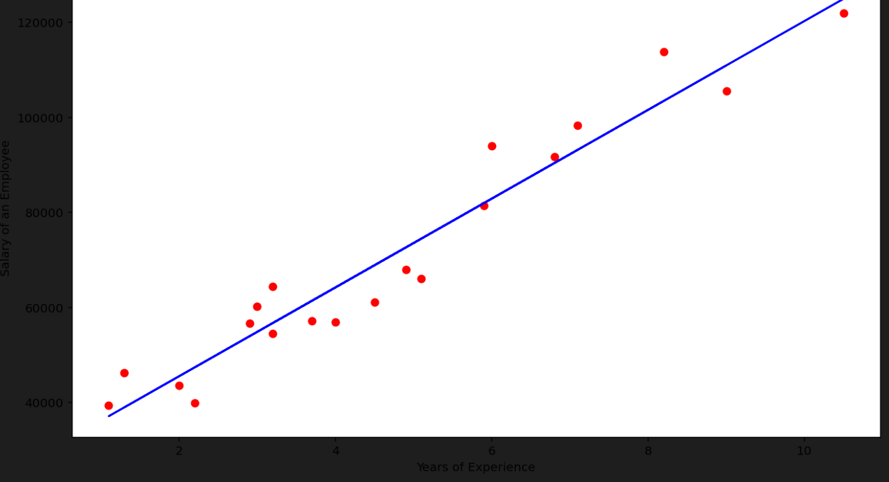

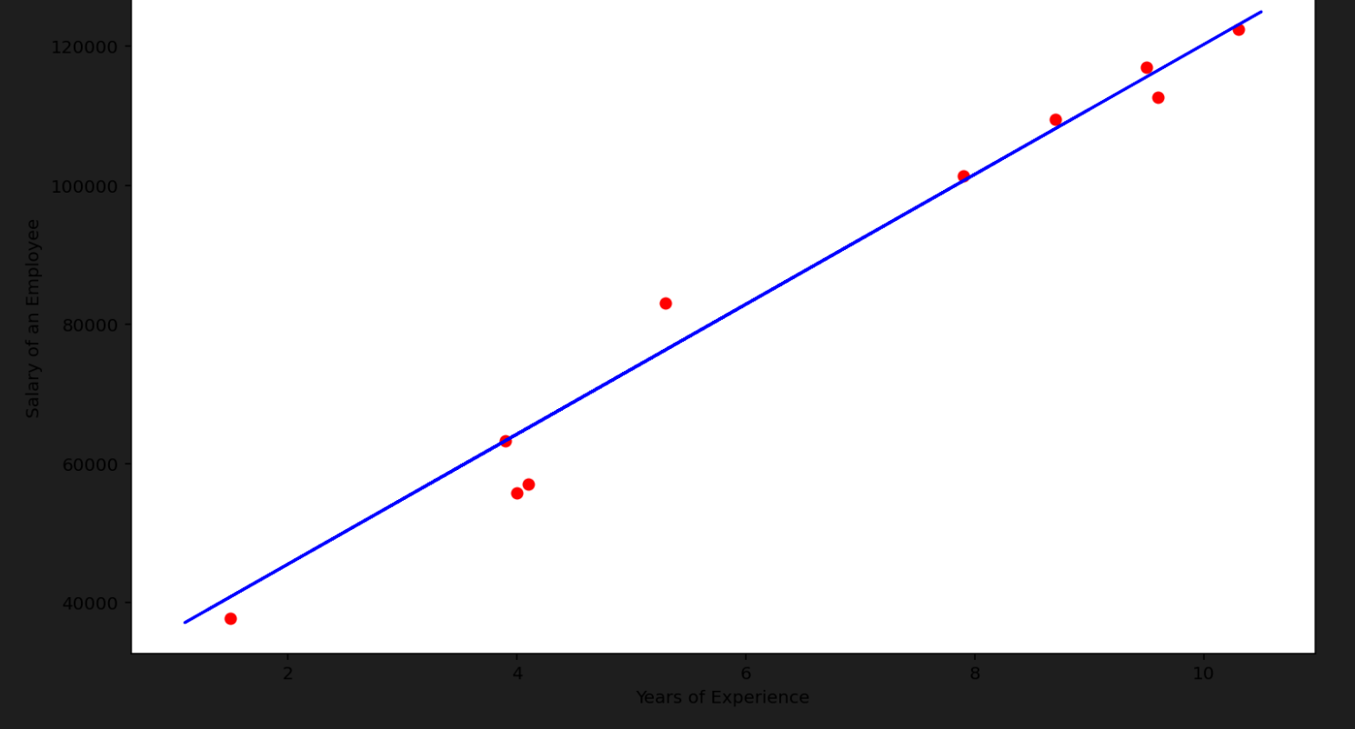

**Difference between predicting and original data for first 10 rows in the dataset**

